**INSTALLING WEKA ON WINDOWS**

**Follow the below steps to install Weka on Windows:**

**Step 1: Visit this website** [**https://www.filehorse.com/download-weka/**](https://www.filehorse.com/download-weka/%20)  **using any web browser. Click on Free Download.**



**Step 2: It will redirect to a new webpage, click on Start Download. Downloading of the executable file will start shortly. It is a big 127 MB file that will take some minutes.**



**Step 3: It will prompt confirmation to make changes to your system. Click on Yes.**

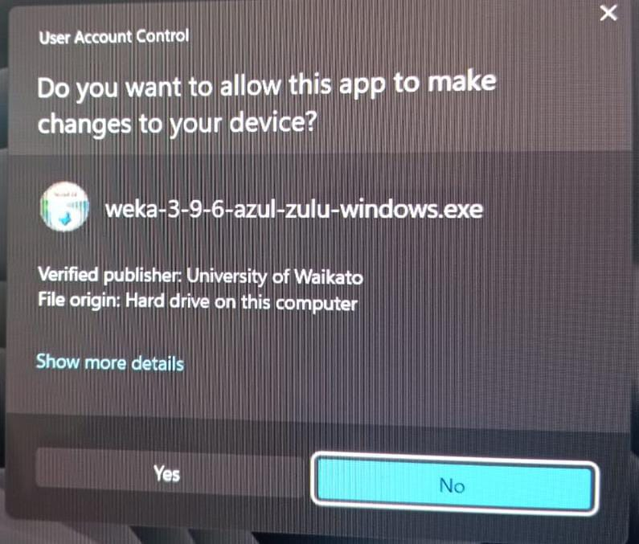

**Step 4: Setup screen will appear, click on Next.**

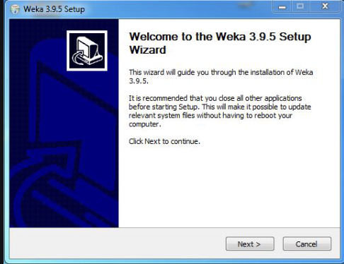

**Step 5: The next screen will be of License Agreement, click on I Agree.**

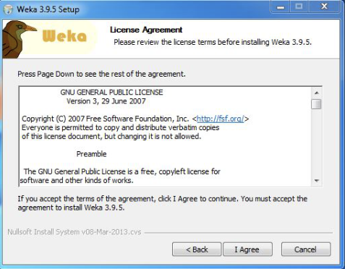

**Step 6: Next screen is of choosing components, all components are already marked so don’t change anything just click on the next button.**

**.**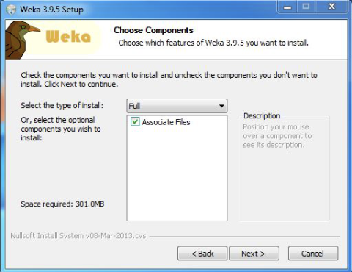

**Step 7: The next screen will be of installing location so choose the drive which will have sufficient memory space for installation. It needed a memory space of 301 MB.**

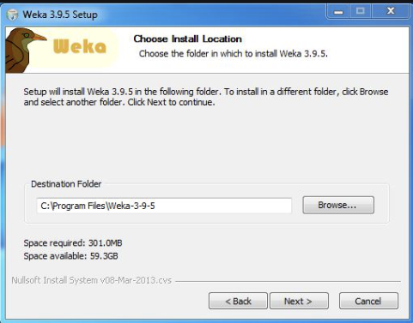

**Step 8: Next screen will be of choosing the Start menu folder so don’t do anything just click on Install Button.**

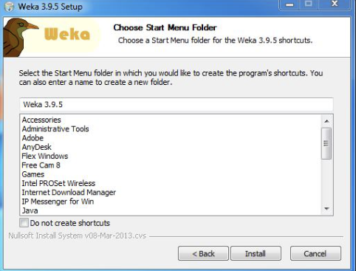

**Step 9: After this installation process will start and will hardly take a minute to complete the installation.**

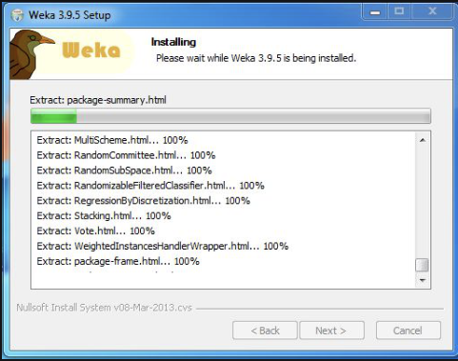

**Step 10: Click on the Next button after the installation process is complete.**

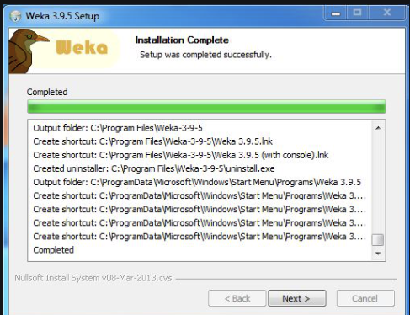

**Step 11: Click on Finish to finish the installation process.**

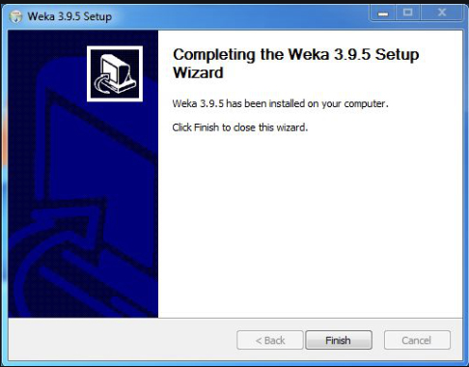

**Step 12: Weka is successfully installed on the system and Run the software and see the interface.**

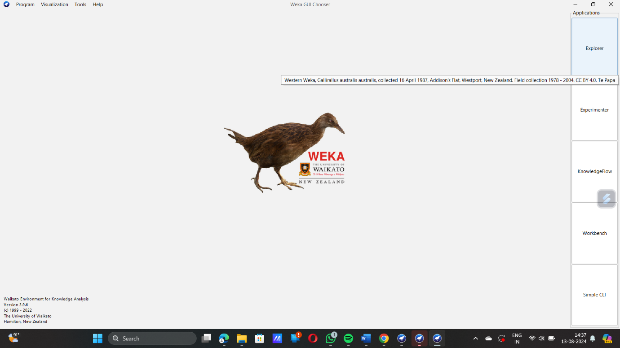

**Congratulations!! At this point, you have successfully installed Weka on your windows system.**